.



* Number of Days : 7
* Budget Per Person : Rs. 70000
* Cities : Dwarka, Somnath, Palitana, Ahmedabad

**Soulful Journey Across Gujarat: Exploring the Land of Temples and Culture**



**Day 1: Arrival in Dwarka**

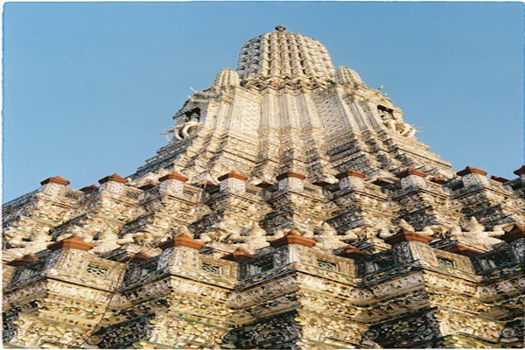

Travel Time: 2 hours  
Travel Distance: 440 km (by Flight)  
Upon arrival in Dwarka, we will check into our hotel and freshen up. In the afternoon, we will visit the Dwarkadhish Temple to seek blessings. In the evening, we can explore the local markets and indulge in some authentic Gujarati cuisine.



**Day 2: Spiritual Awakening in Dwarka**

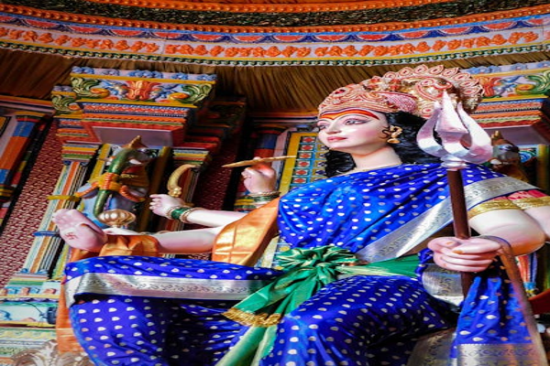

Travel Time: Not Applicable  
Today, we will devote the entire day to exploring the religious sites of Dwarka. We will visit Rukmini Devi Temple, Nageshwar Jyotirlinga Temple, and Bet Dwarka. These sacred sites hold immense significance for Hindu devotees.



**Day 3: Journey to Somnath**



Travel Time: 3 hours  
Travel Distance: 230 km  
After breakfast, we will drive to Somnath. Upon reaching, we will visit the famous Somnath Temple, known for its architectural beauty and spiritual aura. In the evening, we can witness the mesmerizing aarti ceremony at the temple.



**Day 4: Cultural Delights in Somnath**

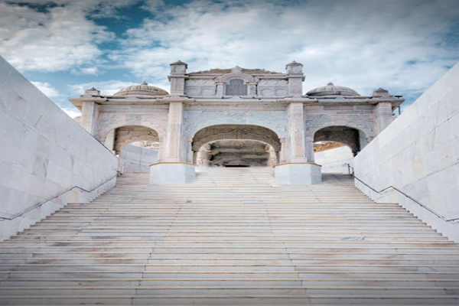

Travel Time: Not Applicable  
Today, we will explore the nearby attractions like Bhalka Tirth, Triveni Sangam, and Somnath Beach. We can also engage in some water sports activities at the beach and savor delicious seafood.



**Day 5: Pilgrimage to Palitana**

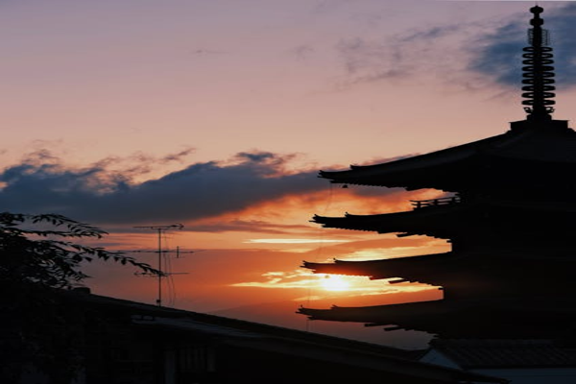

Travel Time: 6 hours  
Travel Distance: 358 km  
We will depart for Palitana, known for its Jain temples. Upon arrival, we will climb the Shatrunjaya Hill to visit the stunning Palitana Temples. The panoramic views from the hilltop are truly mesmerizing.



**Day 6: Heritage Trail in Ahmedabad**

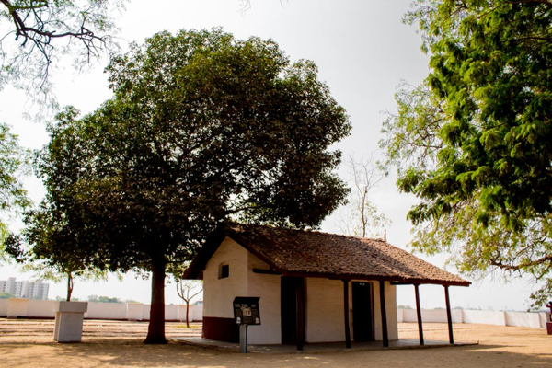

Travel Time: 6 hours  
Travel Distance: 200 km  
We will travel to Ahmedabad, the cultural capital of Gujarat. Here, we will visit Sabarmati Ashram, Jama Masjid, Adalaj Stepwell, and Akshardham Temple. We can also indulge in shopping at Law Garden Market for traditional handicrafts.



**Day 7: Departure from Ahmedabad**



Travel Time: Not Applicable  
On our final day, we will indulge in some last-minute shopping and enjoy a traditional Gujarati meal. We will then proceed to the airport for our journey back home, carrying fond memories of our spiritual and cultural expedition across Gujarat.  
  
This itinerary has been carefully curated to cater to our group's interests in religious sites and fun activities while ensuring a memorable and enriching experience. Let's embark on this soulful journey together and create unforgettable memories.

# Hotel Details

|  |  |  |
| --- | --- | --- |
|  |  |  |
|  |  |  |
| Destination | Hotel | Price per Night |
| Ahmedabad | JW Marriot | 7000.0 |

# Car Details

|  |  |  |
| --- | --- | --- |
|  |  |  |
|  |  |  |
| Destination | Car | Fare |
| Ahmedabad | Hyundai | 1200.0 |

ACCOMODATION